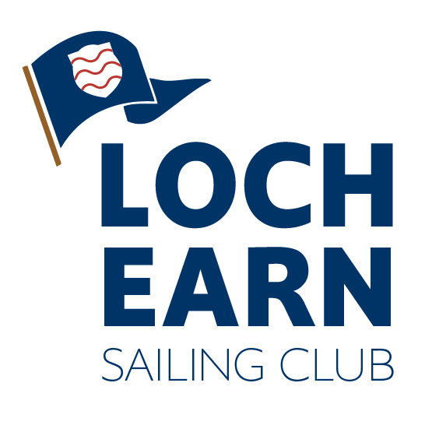

Loch Earn Sailing Club Challenger Traveller
Notice of Race 26/08/23-27/08/23

1. Rules
The regatta shall be governed by the racing rules of sailing RRS 2021 - 2024, the prescriptions of the RYA, the rules of the relevant class and the Sailing Instructions.

2. Entries
The safety of a boat and her entire management including insurance shall be the sole responsibility of the owner / person in charge who must ensure that the boat and crew are adequate to face the conditions that may arise in the course of the race. Neither these sailing instructions nor any inspection of the boat limits or reduces the absolute responsibility of the owner / person in charge for the crew, the boat and her management. The race organisers shall not be responsible for any loss, damage, death or personal injury howsoever caused to the owner / person in charge or crew, as a result of their taking part in the race or races. Moreover, every owner / person in charge warrants the suitability of the boat for the race or races.
Personal buoyancy will be worn at all times, while on the water.

3.Notices to Competitors
Notices to competitors shall be posted on the official notice board located in the clubhouse foyer. This will be signalled by flying flag L from the flagpole at the starter’s hut.

4. Fees
There is no cost to visitors for entry.
For visitors camping, there will be a fee of £3 for the weekend payable at time of registration.

5. Other racing
Be advised it is a cup weekend and there will club racing happening at the same time as the challenger fleet.

6. Facilities
Use of the club kitchen for meals and changing rooms/toilets is permitted. The disabled toilet key is available from within the club house. No formal catering will be offered, but there may be a tuckshop subject to the availability of volunteers.

7. Briefing
The briefing will be at 10 on the day of the first day of racing.

